The Divine Order - The Great Chain of Being
In Elizabethan times, there was a different way of looking at life.
People, including Shakespeare believed in a Divine Order, or Great
Chain of Being. The Divine Order was the belief that everything in
the universe has a specific place and rank in order of their perceived
importance and "spiritual" nature. The more "spirit" a person or object
had, the more power he or she had.

The more spirit an object was thought to have, the higher they would be in the Divine Order. Here is the example of the Divine Order:
Most Amount of Spirit/Highest on the Divine Order
- God
- Angels (seraphim, cherubim)
- Humans (kings, merchants, men women, etc.
- Animals (mouse, dogs, lions, etc.)
- Plants (grass, trees, etc.)
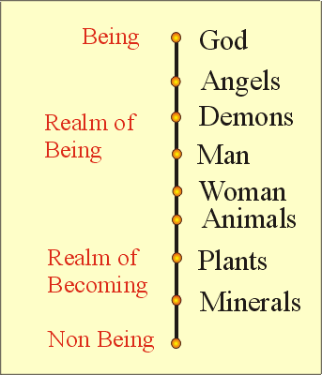
- Least Amount of Spirit/ Lowest on the Divine Order- Nonliving Objects (rocks, metals, etc.)
Within each category there were more specific cataloguing.
For example humans were believed to have different amounts
of spirits. Below is an example of the Divine Order for humans:
Most Amount of Spirit/Highest on the Divine Order
- Kings
- Queens
- Nobles
- Merchants
- Least Amount of Spirit/ Lowest on the Divine Order- Peasants
Within families there was even specific cataloguing. Below
is an example of the Divine Order for humans:
Most Amount of Spirit/Highest on the Divine Order
- Father
- Mothers
- Sons
- Daughter
- Least Amount of Spirit/ Lowest on the Divine Order- Servants
What does all of this mean?
The more "spirit" the person or object had, the more power it had in its
interactions with people or things below in the order. People in
Elizabethan England believed that God set up this order and wanted it
to be followed. If someone or something were to break the Divine Order
by not being obedient to whatever was above it, the person or thing that
went against the God's will would be punished. Bigger betrayals of the
Divine Order were believed to bring bigger punishments by God, while
smaller betrayals would bring about smaller punishments. For example,
if a noble overthrew a king, Elizabethan people thought that a natural
disaster (an earthquake, a hurricane, etc.) would strike. If a daughter
disobeyed her father, Elizabethan people believed the daughter might
fall ill. This was a very convenient way for people higher in the Divine
Order to maintain their power.
What does this have to do with Shakespeare?
Shakespeare sincerely believed in the Divine Order, and
many of his plays revolve around this belief. Macbeth, Taming of the
Shrew, Romeo and Juliet, and Hamlet are just a few of the plays that reflect
Shakespeare's belief in the Great Chain of Being and his desire to
maintain God's Order.

Structure of His Plays

