Eight Ways to Reveal Character by Dewey Hensley

- Actions
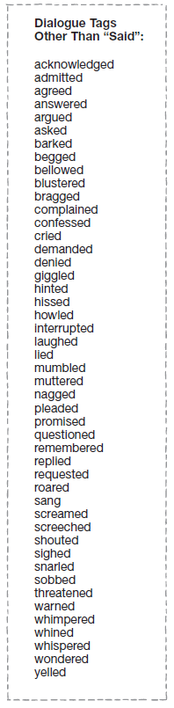
As Kevin moved down the street his feet made a steady echo sound against the pavement. He whistled despite the loud rumble of the traffic and the car horns. When someone yelled out the window of his or her car to watch where he was going, he just waved back like he was watching a best friend heading home. He passed by the garbage on the sidewalk and the old woman pushing the shopping cart filled with newspaper, and continued to smile as he headed toward Cindy’s house. Nothing could erase that smile from his face, not even the coldness of the streets he called home.

- Dialogue
“I ain’t gonna leave you here, Ma’am . . . not with you needin’ help and all,” Jimmy said
as he walked back to his truck to get the jack. “I’d help anybody who needed it; my momma taught me better’en to just leave people. The good Lord’ll make it up to me.”
“I don’t know . . .,” Linda stuttered. She had barely rolled down her window to hear
Jimmy when he had left his pick-up truck and offered help. “You know what they say about your kind . . .”

- Physical Description
Other guys walking through the hallway were taller and even more handsome, but there
was something about Billy Belaire. His arms swung loose at his side and his dark hair was long and pulled back behind his head, held by a rubber band. The dark jacket he wore was straight out of the local thrift shop, she could tell, but the way he wore it suggested a sense of pride, or at least a lack of caring what others thought about him.

- Idiosyncrasies
Junior tapped his fingertips against the table and looked at his watch constantly. His leg
bounced up and down and he gulped the hot coffee as if it would hurry up his friend’s arrival.

- Objects/Possessions
Michael touched the locket around his neck and rolled it between his fingers. His mother had given him that locket, with her picture inside, when he had left to live with his father. What would she think of him now?

- Reactions
Tony’s words stung Laura. It wasn’t what she expected to hear. They had been dating for
over a month now, how could he do this to her? How could he break her heart? All three of their dates had been fun; he had said so himself. As Tony watched the floodgate of her eyes begin to open he looked at his watch. Jeez, I hope I can make it to the gym on time.

- Thoughts
He began to remember when he was a freshman in high school. The seniors really
thought they were something back then, always trying to play their little pranks on the ninth graders. He knew at that moment he couldn’t be one of those kinds of people. He walked over to Jeff and Larry to tell them it was time to stop.

- Background Information
Miles knew what it meant to be alone. When he was a child growing up his father had
been in the military. They had traveled from Florida, to Georgia, to California, to Kentucky. He
had rarely had a friend for very long. By the leap from California he had already decided having
friends was a risk; the fewer the friends, the easier it was to leave. This philosophy had made him
a real outsider at Glenview High School. In the six months he had been there he had not really
made a single friend but as he stood there staring at Sheila, he realized that just might have to
change

Bad Dialogue vs. Good Dialogue

What types of dialogue exist? Internal and External

Key: Specific details that bring the reader in
*Make this scene your place

Dialogue is not filler; dialogue moves the story along and gives us information

Bad dialogue-no information, no movement
The second you get information, you start to get good dialogue: Background info, Unexpected, Conflict

Key: Keep the unexpected and conflict going. We say unexpected things and that’s what keeps us talking to each other.
Use-he said-she said: This allows your conversation to be meaningful and descriptive. See example below with Trevor and Jennifer. This is a great example of showing instead of telling.

Spread dialogue out, so the conflict builds
Interior dialogue-You say one thing, but you’re thinking mountains of things-We rarely say everything we think
“Why do you want to move out? You think you’re better than us?” mom said.
“No mom,” I said.
You don’t want two people vomiting up anything

Show Don’t Tell
Trevor’s comment annoyed Jennifer.
Jennifer gritted her teeth. Trevor was now talking about how stupid tennis was. Did he not notice she was carrying a tennis racket? Was he stupid or a jerk? A stupid jerk.
Checklist:
- Spread out so conflict builds
- Provides information: background info, unexpected, conflict
- Moves story along
- Show, don’t tell (Description!)
- Every time someone speaks is one line
- Internal dialogue is one line
Ideas
- Write a scene of dialogue that creates tension between your protagonist and a supporting character.
- Write a scene of dialogue where your antagonist reveals something to your protagonist.
- Write a scene of dialogue where a supporting character tells your protagonist something that will change the course of the protagonist's actions.
- Write a scene of dialogue that shows how a supporting character and your antagonist interact.
- Write a scene of dialogue that shows the relationship between your protagonist and your antagonist.
6. Write a scene of dialogue that reveals a plot twist!

