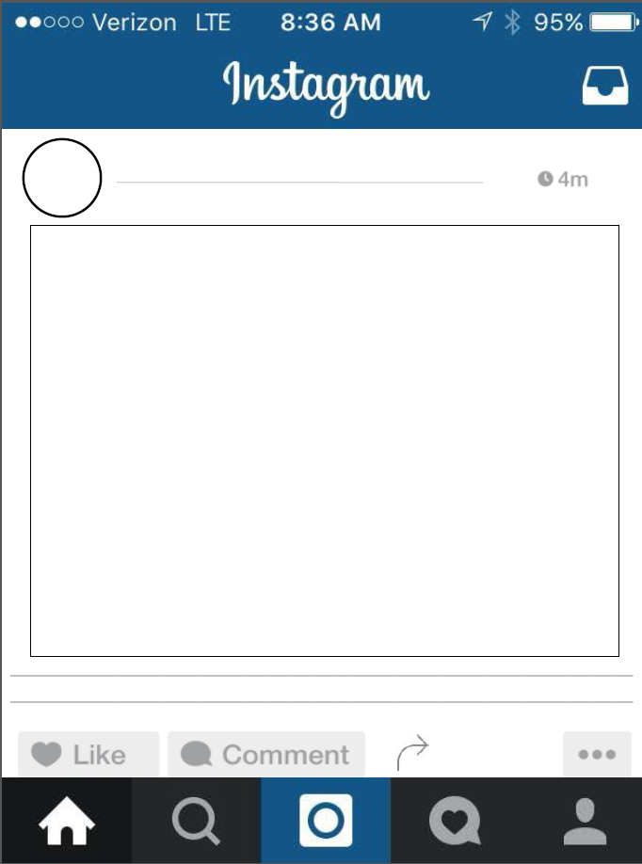
Name: ________________________________________________ Period: _______
Directions: Paste your photo in the box and hand write your hash tags.

