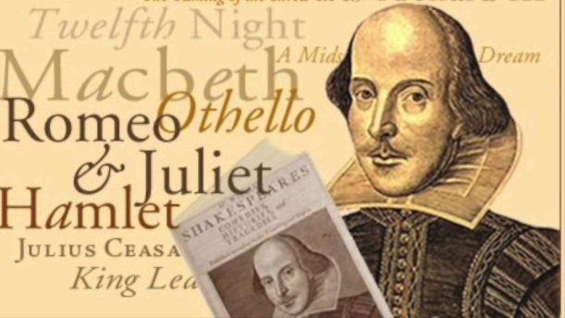
Romeo and Juliet Research Project
Targets: To gain an understanding of Shakespeare and the Elizabethan time period to develop context for the play,
Romeo and Juliet.

- In your group, choose a research topic below:
- Shakespeare's Life: Stratford Beginnings, Success in London, Final Years, An Expansive Age, Shakespeare's Story
- Shakespeare's Work: The Plays and plot structure, The Poems, Publication, First Folio
- Shakespeare’s Theater: The Globe Theater, London Playhouses, Inside the Theaters, Staging and Performance, Business Arrangements
- Elizabethan Life: London in the 1590s, social class structure, marriage, men vs. women
- The Chain of Being: Describe what it is, how it relates to Elizabethan society, how Elizabethans viewed it, and find images of it to share and explain
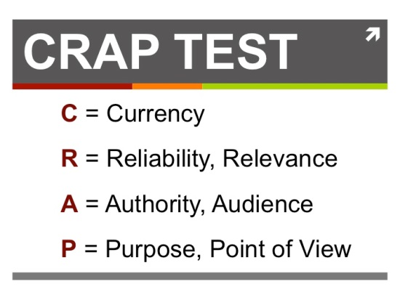
- Shakespeare’s Influence: Some people question Shakespeare’s authorship. What rumors surround his writing? What movies, poems, and novels have been inspired by Shakespeare?
- Conduct research using the following resources:
  - Folger Shakespeare Library website: www.folger.edu, “Discover Shakespeare” link
  - Google: Use various search terms
  - Ebsco databases
Remember to use the CRAP Test for websites

Website | Facts
- Summarize the key points you learn in a T chart.
- Create a visual aid using Google Slides or Prezi.
  - Each member should present at least 2 slides and
create 1 notecard to aide in presenting
  - Include facts, pictures, and video if appropriate
- One slide should include all sources for the group in MLA style.
  - Each person needs at least one source
  - Videos should be cited properly
  - Include one slide of picture web links
- Post your presentation on Google Classroom
- Dress up and present your findings Presentations 4-5 minutes. Verbally cite! Use the handout on the class website.

Name: _________________________________
Grading Rubric
Scoring Criteria | Exemplary  10 | Proficient  9-8 | Emerging  7-6 | Incomplete  5-0 | CCS & Criteria #
IDEAS | is thoughtful and well-organized  demonstrates a comprehensive understanding of significant aspects of the topic and its relevance to the play | is organized and displays a solid understanding of the topic  clearly connects the topic and the for the audience and play | is somewhat organized  contains information that shows a limited understanding of the topic or how it connects to the play | is not well organized and/or does not contain relevant content  provides few or no clear facts and details to help the audience connect the topic and the play | SL.9-10.4; 9-10.1a  1
SL.9-10.1a; SL.9-10.4; W.9-10.9a
2
STRUCTURE | skillfully uses a variety of sources to keep the audience engaged  includes media resources that are used creatively to enhance understanding of the topic | uses sources to engage the audience  uses media effectively to support information about the topic and ideas connecting it to the novel | uses some sources that do not engage the audience  uses media choices that are distracting and do not serve the group’s purpose | does not use sources  does not use media | SL.9-10.5  3
SL.9-10.5: 9-10.4; W.9-10.6
4

USE OF LANGUAGE | demonstrates accomplished oral communication skills and rehearsal to create a well-planned delivery  includes participation by all group members | adequate oral communication skills and rehearsal to plan the delivery  includes participation by all group members, although some may present more than others | demonstrates inadequate oral communication skills and shows little evidence of rehearsal  is delivered by only some of the group members | shows inadequate oral communication skills and no evidence of rehearsal  is not delivered by all group members | SL.9-10.1a; 9-10.6  6
SL9-10.1a
7

______________ / 30

